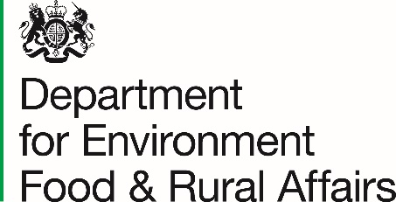
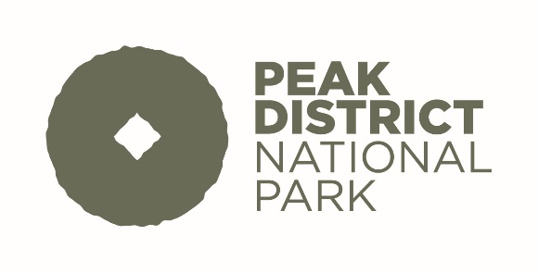

Farming in Protected Landscapes Programme
Farm Visit Evaluation Form
This form should be completed by the agreement holder (Section A) and the leader of the visiting
group (Section B). Please complete the form as fully as possible. All the information you provide is
extremely valuable to us and will help us process claims, review our procedures and improve future farm visits.
Please ensure one form is completed per visit. Further copies of this form are available from https://www.peakdistrict.gov.uk/looking-after/living-and-working/farmers-land-managers.
Visits must meet the requirements of the agreement to be eligible for payment. A single visit is any number of classes/groups on farm at the same time.
The agreement holder must submit the completed form to the Peak District National Park to support the claim. Please keep a copy for your records.
Section A: For completion by Agreement Holder
Agreement Holder Name

Declaration: This visit provided a free learning experience related to either the natural environment; food; farming; and/or the curriculum.

Signature
Section B: For completion by Group Leader
Group Name

Address and Post Code

v1.0 Apr 2022 1

Group Leader’s Name

Contact Telephone Number

E-mail address

I confirm that the visit was free of charge

Signature

Contact details will solely be used by the Peak District National Park should we need to contact you to discuss your visit.

Date of visit

Time of arrival Time of departure

1. Please describe your group/organisation type: (Please tick as relevant)
College/University Open day Visit Social

Pre-school/nursery Health (care farming) Youth Group/club
Environmental School

Other, please specify

2. Please tell us about your group

Age range | 0 - 5 | 6 - 16 | 17 - 24 | 25-64 | 65+
Number of people

v1.0 Apr 2022 2
3. How did you travel here? (please tick)
Bicycle Train Bus/Minibus Car On Foot

4. What activities were undertaken during your visit (please give details of farmer led activity and
curriculum subjects where relevant)?

5. Please add any other comments about your visit.

v1.0 Apr 2022 3
6. How did you find out about educational access at this site?

7. Have you visited before? Yes No

8. Would you visit again? Yes No
9. Were there any challenges and obstacles to overcome before you could visit? (for example
budgets, bus hire, health and safety concerns and so on)

v1.0 Apr 2022 4
10. Why did you choose this farm?

11. For School Visits Only: Please tell us which Key Stage(s) made the visit?

Data protection
For information on how we handle personal data go to https://www.peakdistrict.gov.uk/looking-after/about-us/open-government/data-protection

v1.0 Apr 2022 5

